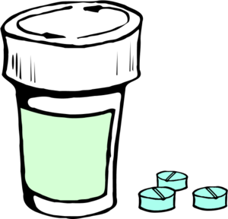
Suggestions for Taking Pills

- Take your pills one a time, especially if they are large
- Try cutting or crushing the really large pills (always double check with nursing or a pharmacist first if this is a new medication to make sure its ok to crush them)
- Take your pills in a spoonful of applesauce, pudding, yogurt, etc. so that they will sit in the food instead of floating around in your mouth
- Sips of water or another drink to help wash them down in between is fine
- Sitting up nice and straight like you would to eat a meal

