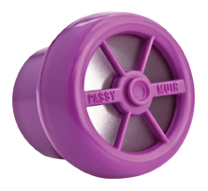
How do you clean the Passy-Muir Valve?

1. Swish Valve daily in soapy, warm water (not hot water).
2. Rinse Valve very thoroughly in warm running water.
3. Allow Valve to air dry thoroughly before placing in storage container. Do not apply heat to dry Valve.
4. DO NOT use hot water, peroxide, bleach, vinegar, alcohol, brushes or cotton swabs to clean Valve.

Remember with your Valve:

- Don’t wear it while sleeping or even napping
- Take the valve off before you cough
-If you cough and phlegm or blood gets in the valve need to clean it before wearing again
-If the valve starts to make funny noises first: make sure it is clean, if cleaning doesn’t fix the problem it may be time to replace it

