Oral Care

Areas of the mouth that need to be cleaned during oral care:
- Teeth (all sides)
- Gums
- Cheeks
- Roof of the mouth (hard palate)
- Back of the mouth (soft plate)
- Tongue

Essential oral care equipment:
- Penlight (to inspect the oral cavity prior to cleaning)
- Tongue depressor (to aid in viewing the oral cavity)
- Sage suction products/Toothbrush and toothpaste
- Oral suction/Yankauer
Additional equipment that may be required or helpful:
- Oral care bite blocks- appropriate to use with patients who are unwilling or unable to cooperate with oral care

Pink swabs alone are not adequate for oral care.
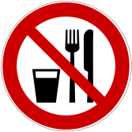
Note: A swallowing assessment may not be able to be completed when oral hygiene is poor, in order to prevent putting the patient in a high risk situation to contract aspiration pneumonia.

